**Stock Chart Marketing**

**MileStone1**

**Name:A.Ishwarya**

**EmployeeId:765521**

**HTML SCREENSHOT**

**Admin Login:**

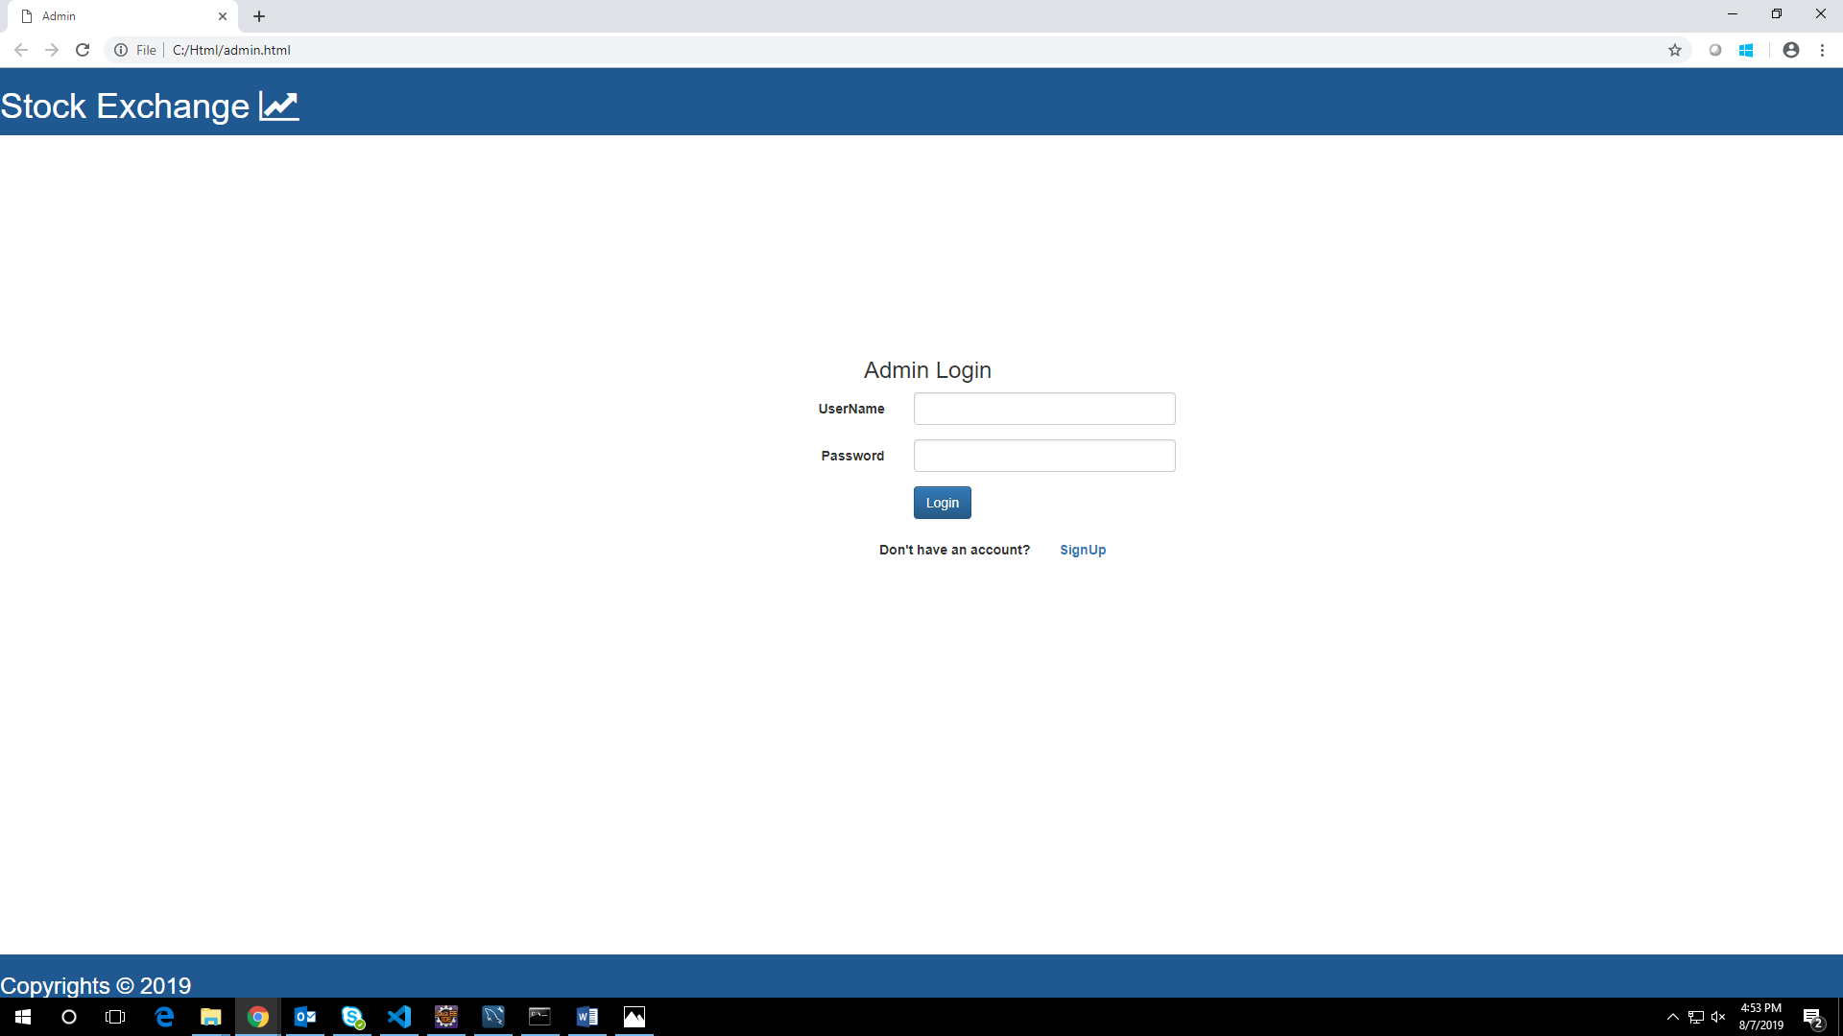

**AdminLandingPage:**

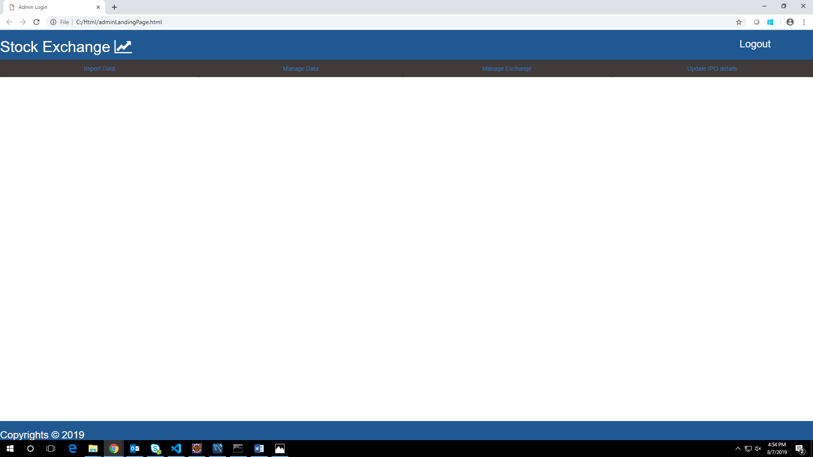

**Import Stock:**

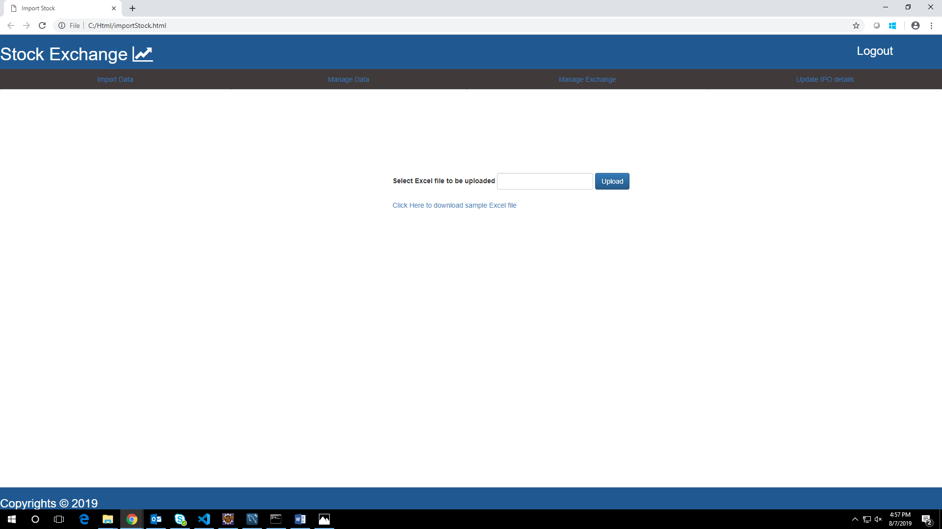

**Summary:**

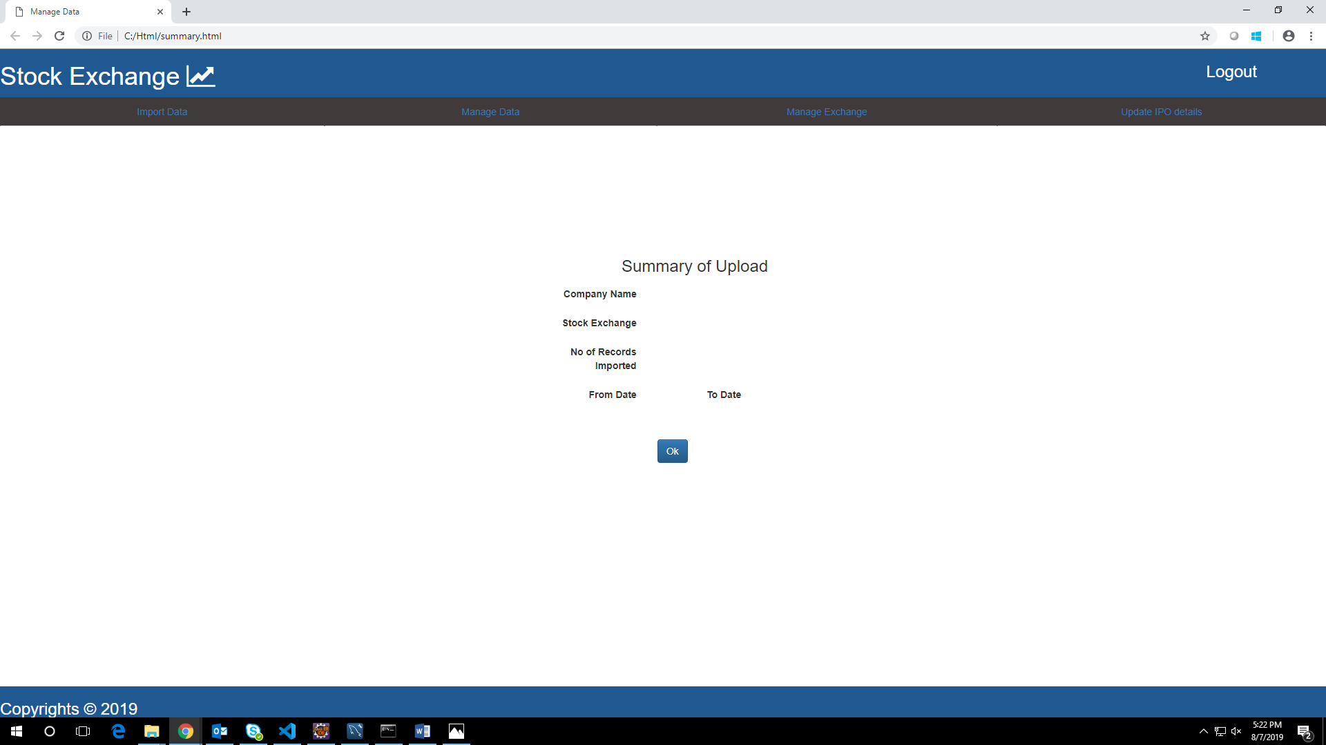

**Insert Company**

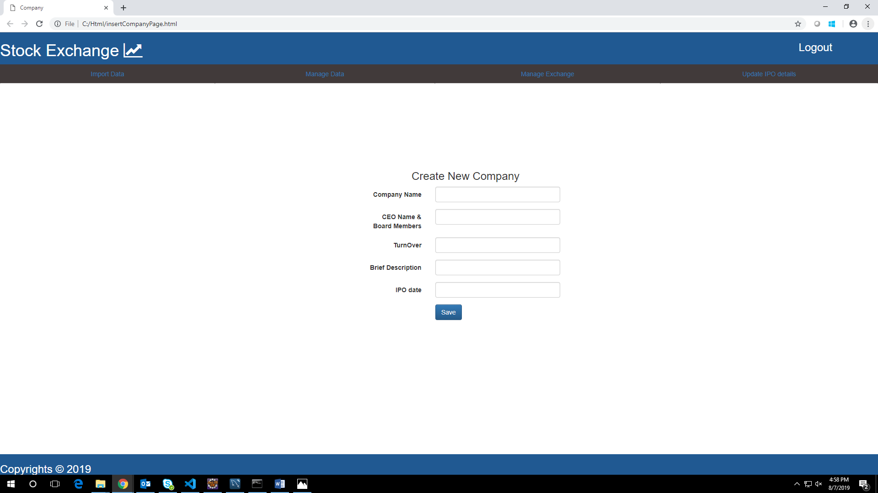

**Comparison:**

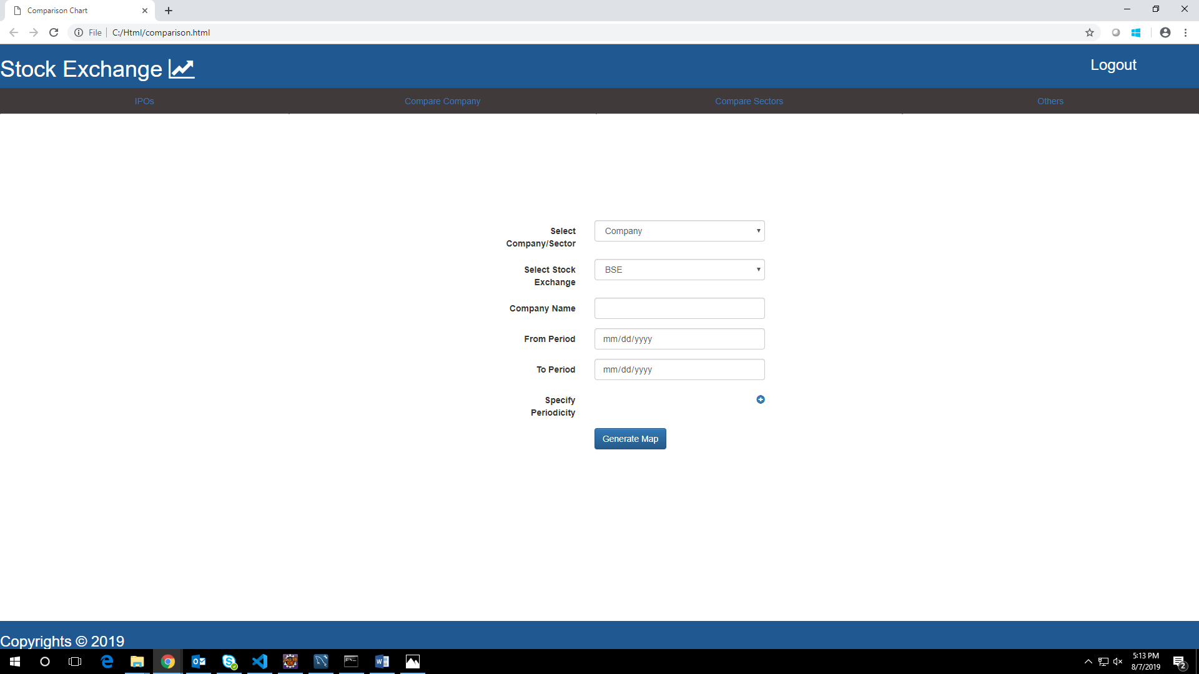

**Manage Company:**

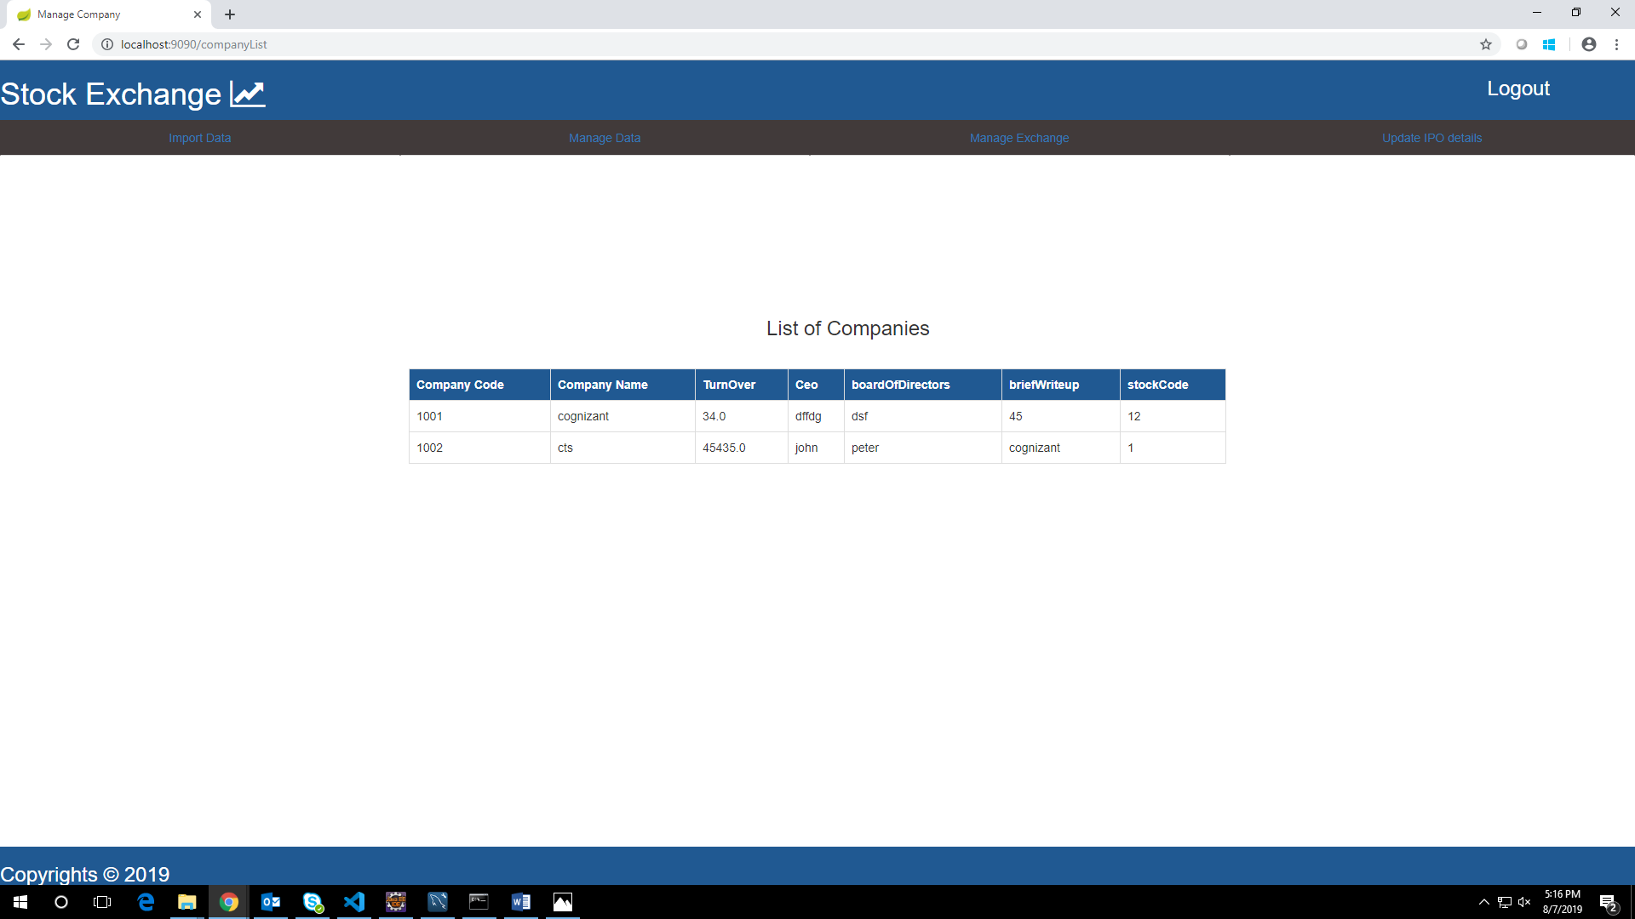

**User Login:**

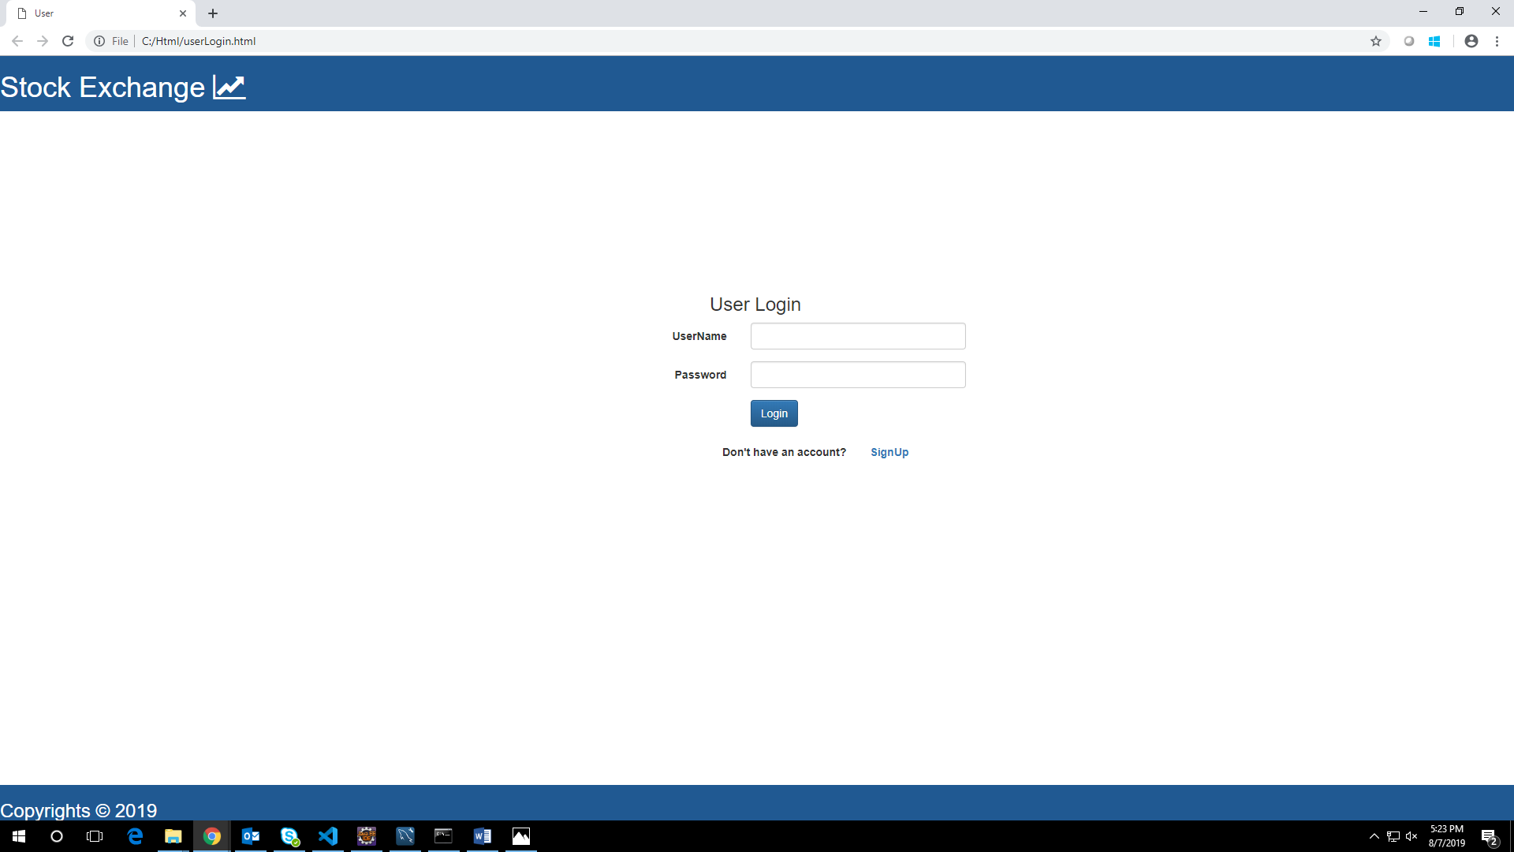

**User SignUp:**

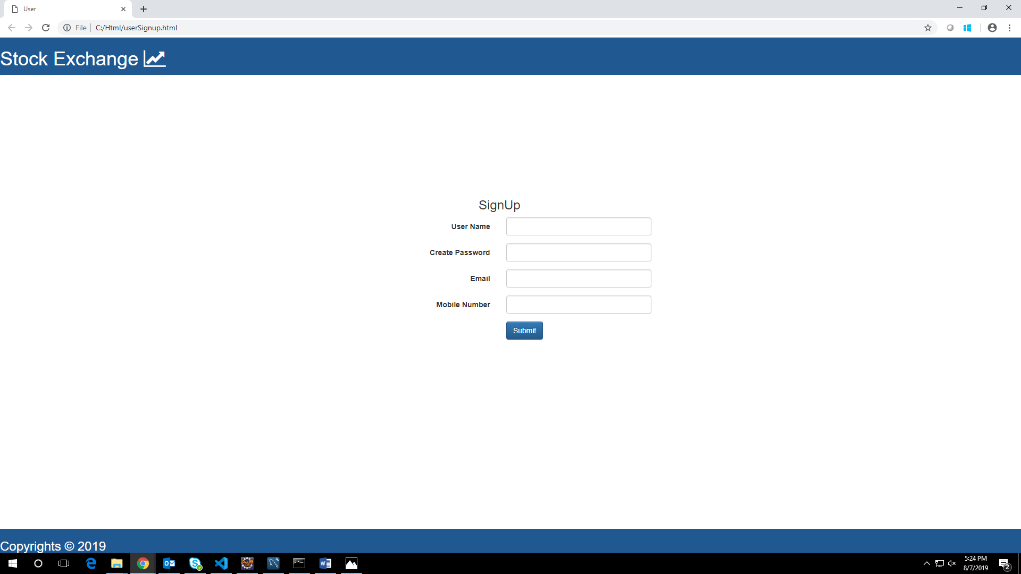

**UserLanding Page:**

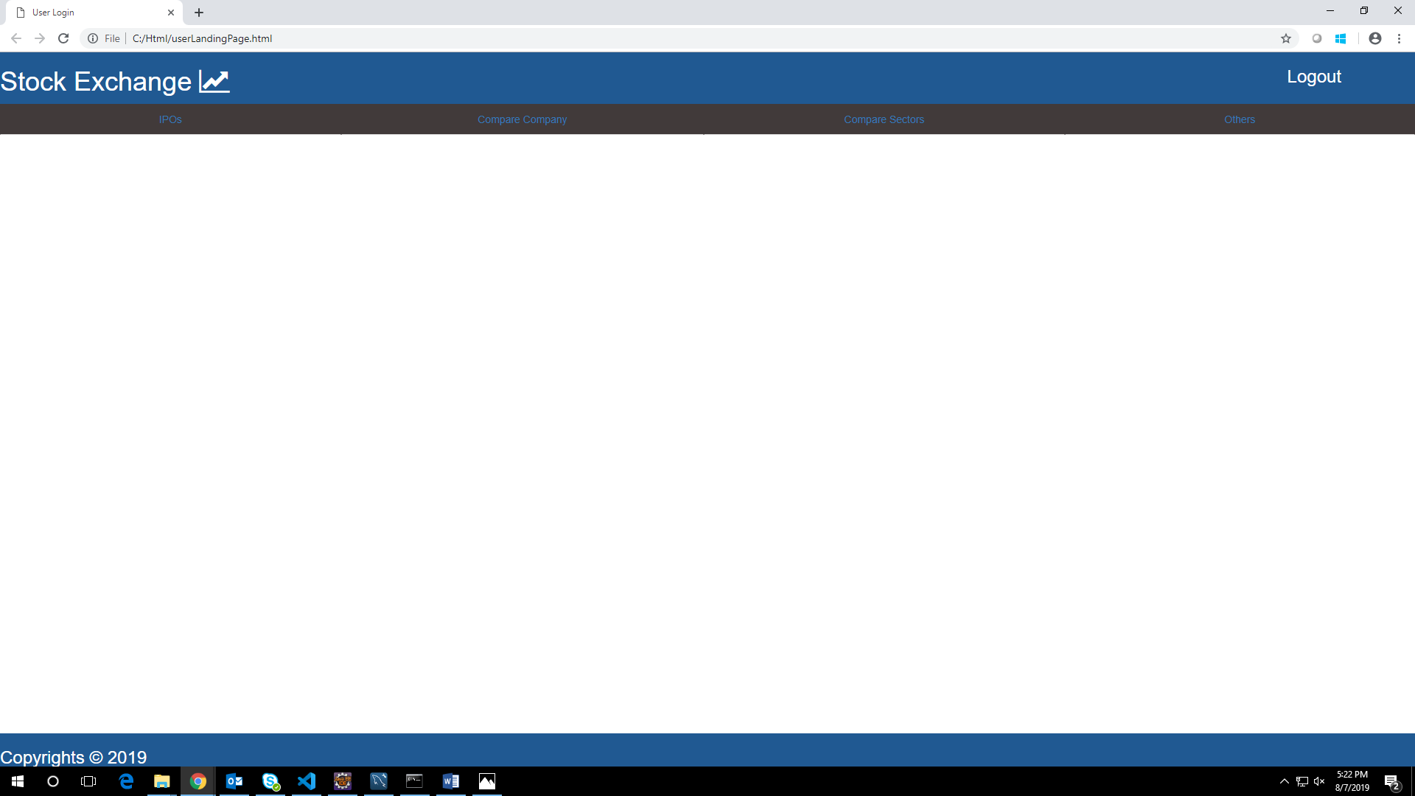

**Schema:**

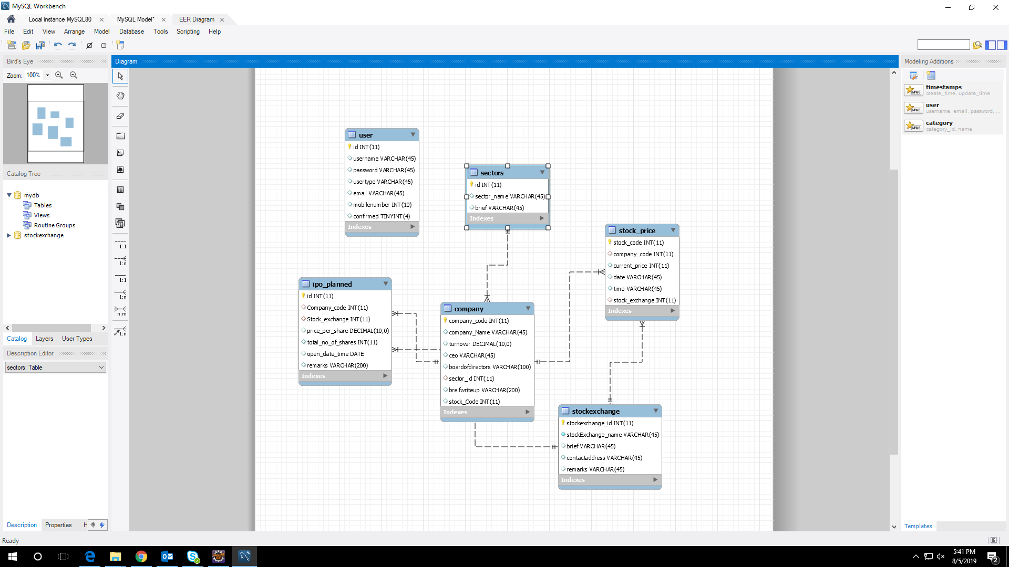

**Github Link:**

[**https://github.com/ishwarya12a/StockExchange**](https://github.com/ishwarya12a/StockExchange)